# SDN Manager Specs:

## General App structure

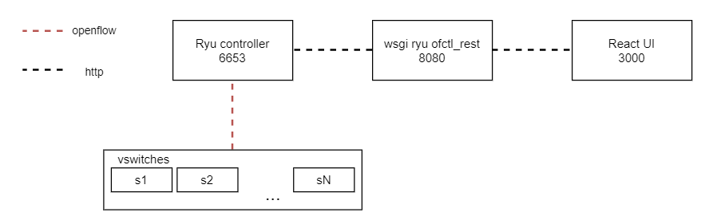

:

* React UI server.
* Ryu server.
* Ryu controller.

### React UI server:

|  |  |
| --- | --- |
| Port | 3000 |
| Description | * Creating and managing interactive UI * Synchronize edit of switch from the UI with the actual state the openflow switch. |

### Ryu server:

|  |  |
| --- | --- |
| Port | 8080 |
| Description | * forward requests between React UI and Ryu Controller. |

### Ryu Controller:

|  |  |
| --- | --- |
| Port | 6653 |
| Description | * receive requests from Ryu server (like adding, editing, or deleting flows) and sending at to the corresponding vSwitch via Openflow massage. |

## Openflow Switches detection

The app detects

## Flow entries

Flow entries can be added or deleted from each switch.